SIMATS ENGINEERING (SAVEETHA SCHOOL OF ENGINEERING)
Department of Computer Science and Engineering
ASSESSMENT TOOL 2 – SCENARIO BASED ASSESSMENT (2 Questions)

Course Code: | ITA05 | Course Title: | COMPUTER VISION
CO Assessed: | CO2 – Manipulation (BL3) | Assessment: | Assessment Tool 2 – Scenario Based Assessment
Weightage: | 20% of CIA | Total Marks: | 20 (2 Questions × 10 Marks)
CO5 Statement: | Apply image enhancement and segmentation techniques for extracting meaningful regions from images.(BL3)
Student Name: | B.Rakesh | Reg. No.: | 192425241
Section / Batch: | B.Tech IT | Date:

Code of Conduct
I S.Adhikesavan - 192521172 (Name / Reg No) certify that this submission is my original work and that I have adhered to the guidelines specified for this assessment. I understand that any violation of academic integrity rules will result in disciplinary action.

Signature of the Student: _________________________

Instructions
- This test contains 2 questions, each carrying 10 marks. Total: 20 Marks.
- No negative marking. Unanswered questions carry zero marks.
- No calculators or electronic devices permitted.
- Duration: 60 minutes.

Section / Topic | Focus Area | Q. Nos. | Marks
Frequency Domain Image Enhancement | Periodic noise removal, Fourier Transform, notch filtering, quality inspection | 1 | 10
Spatial Filtering & Edge-Preserving Enhancement | Bilateral filtering, edge preservation, autonomous vehicle navigation | 2 | 10
GRAND TOTAL: |  | 20 Marks

Annexure A – Scenario Based Assessment

Scenario 1: Manufacturing Quality Inspection
An automated quality inspection system captures images of metal components. Electrical interference introduces repetitive horizontal stripes across the images, making defect detection unreliable.
(a) Interpret the scenario and identify the type of noise present.
(b) Explain how this degradation affects inspection accuracy.
(c) Recommend an appropriate enhancement technique to remove the interference.
(d) Justify why your selected approach is more suitable than spatial-domain methods.
(e) Explain your answer in a logical sequence.

Scenario 2: Autonomous Vehicle Navigation
A self-driving car captures road images during heavy rain. Although noise is present, the lane markings and road edges must remain sharp for safe navigation.
(a) Interpret the scenario and explain the challenge involved.
(b) Identify the importance of preserving edges while removing noise.
(c) Recommend a suitable filtering technique.
(d) Justify why your selected filter preserves important image details.
(e) Present your explanation clearly and systematically.

Solution :

( 1 ) (a) Interpret the scenario and identify the type of noise present.
In an automated manufacturing industry, cameras are used to inspect metal components for defects such as cracks, scratches, dents, holes, and surface irregularities. During image acquisition, electrical interference from nearby motors, power lines, or electronic equipment introduces repetitive horizontal stripes across the captured images. This repetitive pattern is called Periodic Noise.
Periodic noise is different from random noise because it follows a regular repeating pattern. In the frequency domain, it appears as distinct bright points or spikes located away from the center of the Fourier spectrum. These unwanted frequency components interfere with the actual image information, making automated defect detection difficult.

(b) Explain how this degradation affects inspection accuracy.
Periodic noise significantly affects the performance of automated inspection systems.
Effects of degradation:
- Horizontal stripes hide fine surface defects such as scratches and cracks.
- The contrast between defective and non-defective regions decreases.
- Image segmentation algorithms may identify the stripe pattern as defects.
- Edge detection algorithms produce incorrect boundaries.
- Machine vision systems may classify good components as defective (False Positive).
- Actual defects may remain undetected (False Negative).
- Production quality decreases because defective products may pass inspection.
- Repeated inspection increases manufacturing cost and time.
For example, if a tiny crack is present on a metal surface, the horizontal stripes may overlap the crack, making it invisible to the inspection software.

(c) Recommend an appropriate enhancement technique to remove the interference.
The most suitable enhancement technique is the Frequency Domain Notch Filter.
Working Principle
- Capture the noisy image.
- Apply the Fourier Transform (FFT) to convert the image into the frequency domain.
- Identify the bright spikes representing periodic noise.
- Apply a Notch Filter to suppress only those unwanted frequencies.
- Perform the Inverse Fourier Transform (IFFT).
- Obtain a clean image with defects clearly visible.

(d) Justify why your selected approach is more suitable than spatial-domain methods.
The Notch Filter is more effective because periodic noise is concentrated at specific frequencies.
Advantages of Frequency Domain Notch Filter
- Removes only the unwanted periodic frequencies.
- Preserves edges and texture of the metal surface.
- Produces minimal distortion.
- Improves defect visibility.
- Suitable for repetitive stripe patterns.

Limitations of Spatial Filters
Spatial Filter | Limitation
Mean Filter | Blurs the image but cannot remove periodic stripes completely.
Median Filter | Effective for salt-and-pepper noise only.
Gaussian Filter | Reduces random noise but leaves stripe patterns.
Therefore, frequency-domain filtering is the preferred solution for periodic noise.

(e) Explain your answer in a logical sequence.
Step 1: Camera captures the metal component.
⬇
Step 2: Electrical interference introduces horizontal stripe noise.
⬇
Step 3: Image quality decreases.
⬇
Step 4: Convert image to frequency domain using FFT.
⬇
Step 5: Detect periodic frequency spikes.
⬇
Step 6: Apply Notch Filter.
⬇
Step 7: Perform inverse FFT.
⬇
Step 8: Obtain enhanced image.
⬇
Step 9: Automated inspection accurately detects defects.
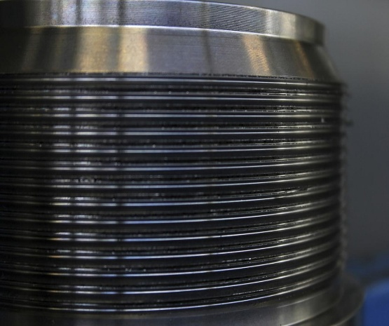

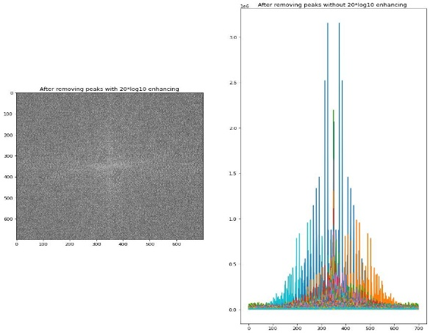

Fig 1 : Metal Component with Fig 2 : Frequency Domain Notch Filter
Periodic Horizontal Stripe Noise Diagram

Solution 2 :

(a) Interpret the scenario and explain the challenge involved.
Autonomous vehicles depend on cameras to recognize lanes, pedestrians, traffic signs, vehicles, and obstacles. During heavy rain, water droplets and atmospheric disturbances introduce random noise into the captured images.
The challenge is that while removing this noise, the important structures such as lane markings, road boundaries, and object edges must remain sharp. If these edges become blurred, the vehicle may fail to recognize its driving path, leading to unsafe navigation.

(b) Identify the importance of preserving edges while removing noise.
Edge preservation is essential because edges represent the boundaries of important objects.
Importance of edge preservation
- Detects lane markings accurately.
- Identifies road boundaries.
- Helps recognize vehicles and pedestrians.
- Improves traffic sign recognition.
- Enables accurate obstacle detection.
- Supports safe steering decisions.
- Prevents lane departure.
- Enhances overall driving safety.
If lane markings become blurred after filtering, the navigation algorithm may fail to determine the correct lane position.
(c) Recommend a suitable filtering technique.
The recommended technique is the Bilateral Filter.
Working Principle
The Bilateral Filter smooths the image while considering two factors:
- Spatial Distance: Nearby pixels influence each other.
- Intensity Difference: Pixels with similar brightness are averaged.
Pixels separated by strong edges have little influence on each other, allowing edges to remain sharp.

(d) Justify why your selected filter preserves important image details.
The Bilateral Filter is superior because it performs edge-preserving smoothing.
Advantages
- Removes random noise.
- Preserves lane boundaries.
- Maintains road edge sharpness.
- Improves image contrast.
- Prevents blurring of important objects.
- Enhances performance of lane detection algorithms.
- Improves pedestrian detection.
- Produces high-quality images suitable for autonomous navigation.

Comparison
Filter | Performance
Mean Filter | Removes noise but blurs edges.
Gaussian Filter | Smooths image but weakens lane markings.
Median Filter | Best for salt-and-pepper noise only.
Bilateral Filter | Removes noise while preserving edges.

(e) Present your explanation clearly and systematically.

Step 1: Vehicle camera captures the road.
⬇
Step 2: Heavy rain introduces random noise.
⬇
Step 3: Lane markings become difficult to detect.
⬇
Step 4: Apply Bilateral Filter.
⬇
Step 5: Noise is reduced.
⬇
Step 6: Lane markings and road edges remain sharp.
⬇
Step 7: Vision algorithms detect lanes accurately.
⬇
Step 8: Vehicle makes safe driving decisions.

Rubrics for Calculation
Criteria | Weightage (%) | Level 4 (Exemplary) | Level 3 (Proficient) | Level 2 (Developing) | Level 1 (Beginning) | Marks
Understanding of Scenario | 20% | Demonstrates clear and complete understanding of the scenario and context | Shows good understanding with minor gaps | Partial understanding; misses key aspects | Misinterprets or fails to understand the scenario
Identification of Key Issues | 20% | Accurately identifies all relevant issues and factors involved | Identifies most key issues with minor omissions | Identifies limited issues; some irrelevant points | Unable to identify key issues
Application of Concepts | 25% | Applies appropriate concepts effectively to address the scenario | Applies concepts with minor errors | Limited or partially correct application | Unable to apply relevant concepts
Decision Making | 20% | Makes well-reasoned, logical decisions with strong rationale | Makes reasonable decisions with some justification | Makes weak decisions with limited justification | No clear decisions made or rationale provided
Clarity of Response | 15% | Response is clear, structured, and logically presented | Generally clear with minor issues | Somewhat unclear or poorly structured | Disorganized and difficult to understand

Faculty In-charge | Course Coordinator | Head of Department
Signature: _______________ | Signature: _______________ | Signature: _______________
Date: ___________________ | Date: ___________________ | Date: ___________________

